Software Documentation

1. Software Overview
- Used MicroPython
  - Used for the hardware, web hosting and overall logic, acting as a communicator between the ESP32 and other components. The code continuously monitors the LDR and push button values and controls the NeoPixel animation from a single GPIO pin. It interfaces the MPU 6050 for gyroscope coordinates using I2C communication. MicroPython’s “socket” and “network” libraries allowed the ESP32 to turn into a web server, which hosted 2 HTML webpages.

We used Generative AI and the Webpage code from the GitHub repo to code 2 webpages

- Used HTML to create the Instructions/Home page and Game page
  - CSS handled the visual elements of the webpages. It handles only the static appearance elements like the HUD bar, fonts and colour.
- Game physics created using JavaScript engine
  - Created a game loop, visuals and timer
  - Managed the data exchange between MPU-6050 and browser game by using JSON to poll gyroscope data (/gyro) and turning physical movements into crosshair movements onscreen
  - Hits the drones when the crosshair is close enough

In our code, HTML, CSS and JavaScript are used together and packed into Python strings to send to the socket connection. The ‘html1 = b”””….””” block is written in Python but contains HTML, CSS and JavaScript all in one. Despite using Generative AI, we had to understand what each line of code meant so we could trouble-shoot manually or with AI.

2. System Logic
- LDR activated by darkness
- When LDR reads high (1), NeoPixel writes white to all LEDs via ESP 32
- User presses button
- Button cycles through list of colours via ESP32
- New colour written to the NeoPixel on each press
- Simultaneously, ESP32 runs a web server and Wi-Fi network called “StarWars- ODT”
- Connection to Wi-Fi and opening the browser with IP address takes user to the home page
- User clicks “Start”
- Game page loaded (HTML)
- User tilts and moves MPU 6050 (in the hilt)
- ESP32 polls gyroscope data
- Gyroscope data is used to move the on-screen pointer to physically aim and hit drones

3. Flowchart
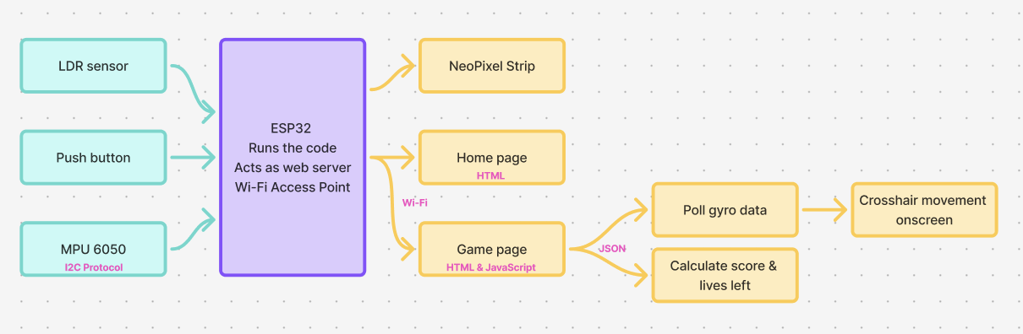
Made on FigJam

4. App Flow (If MIT App Inventor)
- NA

